
PYTHON
STARTTHECODE

[Date]
[Company name]
[Company address]

Comprehensive Python Course Outline

Week 1-2: Introduction to Python

Module 1: Getting Started with Python
- Introduction to Python and its history
- Installing Python and setting up the development environment
- Using Python IDEs (PyCharm, VS Code, Jupyter Notebook)

Module 2: Python Basics
- Syntax and semantics
- Variables and data types (int, float, string, boolean)
- Basic operations (arithmetic, comparison, logical)
- Input and output functions (input(), print())

Week 3-4: Control Structures and Functions

Module 3: Control Structures
- Conditional statements (if, elif, else) , Loops (for, while)
- Loop control statements (break, continue, pass)

Module 4: Functions
- Defining and calling functions
- Function arguments and return values
- Scope and lifetime of variables
- Recursion

Week 5-6: Data Structures

Module 5: Lists and Tuples
- Creating and accessing lists
- List methods and operations
- List comprehensions
- Tuples and their uses

Module 6: Dictionaries and Sets
- Creating and accessing dictionaries
- Dictionary methods and operations
- Sets and their uses
- Set operations

Week 7-8: Modules, Packages, and File Handling

Module 7: Modules and Packages PROJECT Weather using pip library
- Importing modules and using standard libraries
- Creating and using custom modules
- Installing and using third-party packages (pip)

Module 8: File Handling
- Reading from and writing to files
- Error handling and exceptions

Week 9-10: Object-Oriented Programming (OOP)

Module 9: OOP Basics
- Classes and objects
- Methods and attributes
- __init__ method (constructor)
- Inheritance and polymorphism
- Encapsulation and abstraction

Module 10: Advanced OOP Concepts
- Magic methods and operator overloading
- Class and static methods
- Exception classes

Week 11-12: Practical Applications and Projects

Module 13: Real-World Applications
- GUI development with Tkinter

Python Programming Language

Python is a widely used programming language that offers several unique features and advantages compared to languages like Java and C++. Our Python tutorial thoroughly explains Python basics and advanced concepts, starting with installation, conditional statements, loops, built-in datastructures, Object-Oriented Programming, Generators, Exception Handling, Python RegEx, and many other concepts. This tutorial is designed for beginners and working professionals.
In the late 1980s, Guido van Rossum dreamed of developing Python. The first version of Python 0.9.0 was released in 1991. Since its release, Python started gaining popularity. According to reports, Python is now the most popular programming language among developers because of its high demands in the tech realm.

Features of Python:
- Easy to use and Read - Python's syntax is clear and easy to read, making it an ideal language for both beginners and experienced programmers. This simplicity can lead to faster development and reduce the chances of errors.
- Dynamically Typed - The data types of variables are determined during run-time. We do not need to specify the data type of a variable during writing codes.
- High-level - High-level language means human readable code.
- Compiled and Interpreted - Python code first gets compiled into bytecode, and then interpreted line by line. When we download the Python in our system form org we download the default implement of Python known as CPython. CPython is considered to be Complied and Interpreted both.

Java vs. Python
Python is an excellent choice for rapid development and scripting tasks. Whereas Java emphasizes a strong type system and object-oriented programming.
Here are some basic programs that illustrates key differences between them.

Printing 'Hello World'
Python Code:
- print("Hello World)"
In Python, it is one line of code. It requires simple syntax to print 'Hello World'

Getting Started with Python
Python is a versatile, high-level programming language that is widely supported across all major operating systems.
To execute Python code, you need to have a Python interpreter installed on your system. However, if you want to start immediately, you can use our free online Python editor that enables you to run Python code directly in your browser—no installation required.
For those who prefer to install Python on your computer, this guide will walk you through the installation process on Windows, macOS, and Linux (Ubuntu).
Windows
Linux
MacOS

Install Python on Windows
To install Python on your Windows, just follow these steps:
- Install VS Code
- Download Python Installer File
- Run the Installer
- Install Python
- Verify your installation
Here is a detailed explanation of each of the steps:

Step 1: Install VS Code
Go to the VS Code Official website and download the Windows installer. Once the download is complete, run the installer and follow the installation process.
Click Finish to complete the installation process

Step 2: Download the Python Installer File
Go to the official Python website and download the latest version (Python 3.12.2 at the time of writing this tutorial) for Windows.
The website automatically detects your operating system and gives you the right installer.
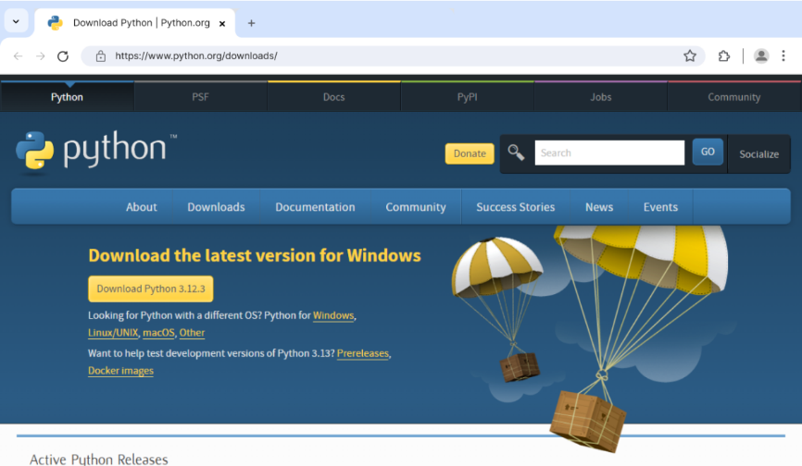
Python Download Page

Step 3: Run the Installer
Now, go to your download folder and run the installer you just downloaded. Depending on your security settings, you might be prompted to allow access.
Simply allow it and proceed.

Step 4: Install Python
Once you have run the installer, you will come across this screen.
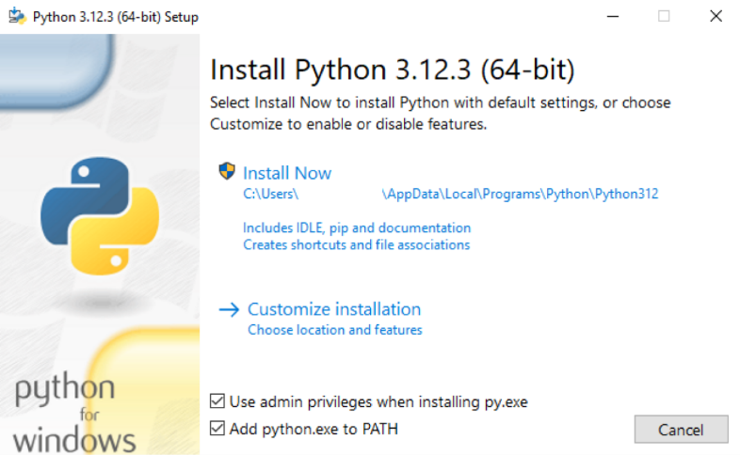Install Python on Windows
On the screen, you will see two options: Install Now and Customize Installation. We suggest you skip all customization steps and simply click Install Now.
- Check on Add python.exe to PATH as it ensures Python is added to our system's PATH variable.(Recommended)
- Click Install Now, as it will include all the necessary files needed later.
This makes it easier to run a Python Program from the command prompt (cmd) directly without specifying the full path of the Python executable.
After using this option, Python will be successfully installed in your device.
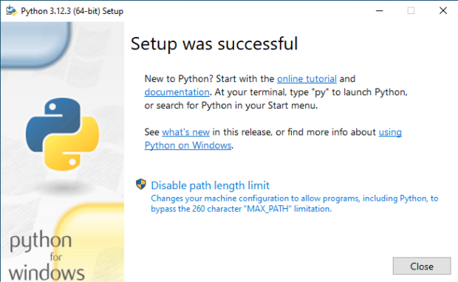
Python Default Installation

Step 4: Verify your installation
After the installation is complete, you can verify whether Python is installed by using the following command in the command prompt.
python --version
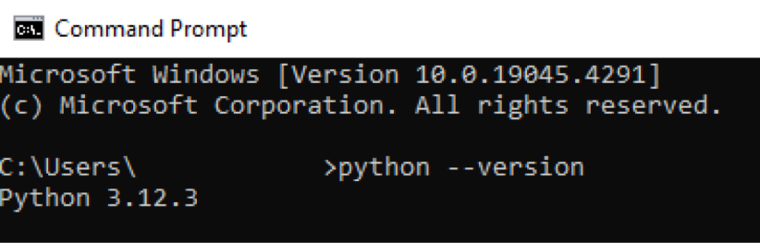Python Installation Verify
Note: The version number might differ from the one above, depending on your installed version.
Now, you are all set to run Python programs on your device.

Run Your First Python Program
First open VS Code, click on the File in the top menu and then select New File.
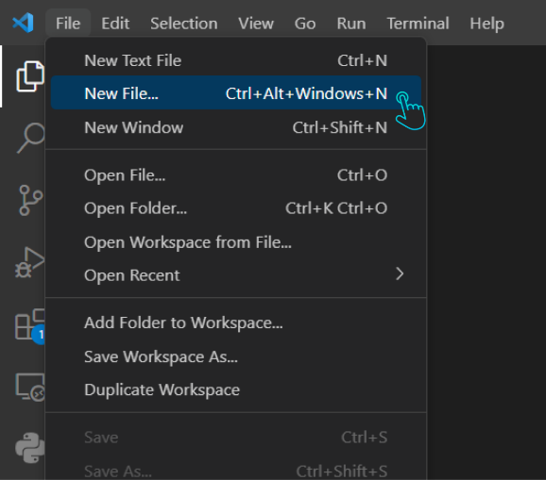Create a New File in VS Code
Then, save this file with a .py extension by clicking on File again, then Save As, and type your filename ending in .py. (Here, we are saving it as Hello_World.py)
Before you start coding, make sure the Python extension is installed in VS Code. Open VS Code and click on Extensions on the left sidebar. Then, search for the Python extension by Microsoft and click on install.
Now, write the following code into your file:
print("Hello World")
Then click on the run button on the top right side of your screen.
Python Run Program
You should see Hello World printed to the command prompt.

Your First Python Program
In the previous tutorial, you learned how to install Python on your computer. Now, let's write a simple Python program.
The following program displays Hello, World! on the screen.
print("Hello, World!")
Run Code
Output
Hello World!
Note: A Hello World program is used to introduce a new programming language. It is the first program that every beginner writes.
It's okay if you don't understand how the program works. We will learn all about them in upcoming tutorials. For now, just write the exact program and run it.

Working of the Program
Congratulations on writing your first Python program. Now, let's see how the above program works.
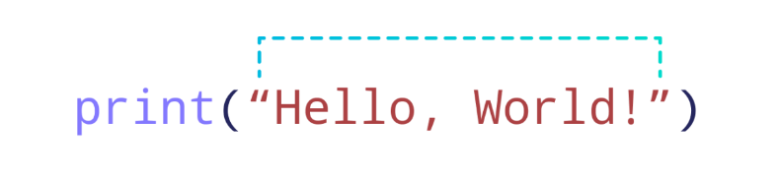
Hello World Code
In Python, anything inside print() is displayed on the screen.
There are two things to note about print():
- Everything we want to display on the screen is included inside the parentheses ().
- The text we want to print is placed within double quotes " ".
We can also use single quotes to print text on the screen. For example,
print('Hello World!')
Run Code
is same as
print("Hello World!")
Run Code
To be consistent, we will be using double quotes throughout the tutorials.
Next, we will be learning about Python comments.

Python Comments
In the previous tutorial, you learned to write your first Python program. Now, let's learn about Python comments.
Important!: We are introducing comments early in this tutorial series because we will be using them to explain the code in upcoming tutorials.
Comments are hints that we add to our code to make it easier to understand. Python comments start with #. For example,
# print a number
print(25)
Run Code
Here, # print a number is a comment.
Comments are completely ignored and not executed by code editors.
Important: The purpose of this tutorial is to help you understand comments, so you can ignore other concepts used in the program. We will learn about them in later tutorials.

Single-line Comment
We use the hash (#) symbol to write a single-line comment. For example,
# declare a variable
name = "John"

# print name
print(name) # John
Run Code
In the above example, we have used three single-line comments:
- # declare a variable
- # print name
- # John
A single-line comment starts with # and extends up to the end of the line. We can also use single-line comments alongside the code:
print(name) # John
Note: Remember the keyboard shortcut to apply comments. In most text editors, it's Ctrl + / if you are on Windows & Cmd + / if you are on a Mac.

Multiline Comments
Unlike languages such as C++ and Java, Python doesn't have a dedicated method to write multi-line comments.
However, we can achieve the same effect by using the hash (#) symbol at the beginning of each line.
Let's look at an example.
# This is an example of a multiline comment
# created using multiple single-line commenced
# The code prints the text Hello World
print("Hello, World!")
Run Code
We can also use multiline strings as comments like:
'''This is an example
of multiline comment'''
print("Hello, World!")
Run Code
Output
Hello World
Note: Remember you will learn about these programming concepts in upcoming tutorials. For now. you can just focus on the usage of comments.

Prevent Executing Code Using Comments
Comments are valuable when debugging code.
If we encounter an error while running a program, instead of removing code segments, we can comment them out to prevent execution. For example,
number1 = 10
number2 = 15

sum = number1 + number2

print("The sum is:", sum)
print("The product is:", product)
Run Code
Here, the code throws an error because we have not defined a product variable. Instead of removing the line causing an error, we can comment it.
For example,
number1 = 10
number2 = 15

sum = number1 + number2

print("The sum is:", sum)
# print('The product is:', product)
Run Code
Output
The sum is 25
Here, the code runs without any errors.
We have resolved the error using a comment. Now if you need to calculate the product in the near future, you can uncomment it.
Note: This approach comes in handy while working with large files. Instead of deleting any line, we can use comments and identify which one is causing an error.

Why Use Comments?
We should use comments:
- For future references, as comments make our code readable.
- For debugging.
- For code collaboration, as comments help peer developers to understand each other's code.
Note: Comments are not and should not be used as a substitute to explain poorly written code. Always try to write clean, understandable code, and then use comments as an addition.
In most cases, always use comments to explain 'why' rather than 'how' and you are good to go.
Next, we will start learning fundamental concepts of Python programming.

Python Variables and Literals
In the previous tutorial you learned about Python comments. Now, let's learn about variables and literals in Python.

Python Variables
In programming, a variable is a container (storage area) to hold data. For example,
number = 10
Here, number is a variable storing the value 10.

Assigning values to Variables in Python
As we can see from the above example, we use the assignment operator = to assign a value to a variable.
# assign value to site_name variable
site_name = 'programiz.pro'

print(site_name)

# Output: programiz.pro
Run Code
Output
apple.com
In the above example, we assigned the value programiz.pro to the site_name variable. Then, we printed out the value assigned to site_name
Note: Python is a type-inferred language, so you don't have to explicitly define the variable type. It automatically knows that programiz.pro is a string and declares the site_name variable as a string.

Changing the Value of a Variable in Python
site_name = 'programiz.pro'
print(site_name)

# assigning a new value to site_name
site_name = 'apple.com'

print(site_name)
Run Code
Output
programiz.pro
apple.com
Here, the value of site_name is changed from 'programiz.pro' to 'apple.com'.

Example: Assigning multiple values to multiple variables
a, b, c = 5, 3.2, 'Hello'

print (a) # prints 5
print (b) # prints 3.2
print (c) # prints Hello
Run Code
If we want to assign the same value to multiple variables at once, we can do this as:
site1 = site2 = 'programiz.com'

print (x) # prints programiz.com
print (y) # prints programiz.com
Run Code
Here, we have assigned the same string value 'programiz.com' to both the variables site1 and site2.
Rules for Naming Python Variables

Python Literals
Literals are representations of fixed values in a program. They can be numbers, characters, or strings, etc. For example, 'Hello, World!', 12, 23.0, 'C', etc.
Literals are often used to assign values to variables or constants. For example,
site_name = 'programiz.com'
In the above expression, site_name is a variable, and 'programiz.com' is a literal.
There are different types of literals in Python. Let's discuss some of the commonly used types in detail.

Python Numeric Literals
Numeric Literals are immutable (unchangeable). Numeric literals can belong to 3 different numerical types: Integer, Float, and Complex.

1. Integer Literals
Integer literals are numbers without decimal parts. It also consists of negative numbers. For example, 5, -11, 0, 12, etc.

2. Floating-Point Literals
Floating-point literals are numbers that contain decimal parts.
Just like integers, floating-point numbers can also be both positive and negative. For example, 2.5, 6.76, 0.0, -9.45, etc.

3. Complex Literals
Complex literals are numbers that represent complex numbers.
Here, numerals are in the form a + bj, where a is real and b is imaginary. For example, 6+9j, 2+3j.

Python String Literals
In Python, texts wrapped inside quotation marks are called string literals..
"This is a string."
We can also use single quotes to create strings.
'This is also a string.'

Python Type Conversion
In programming, type conversion is the process of converting data of one type to another. For example: converting int data to str.
There are two types of type conversion in Python.
- Implicit Conversion - automatic type conversion
- Explicit Conversion - manual type conversion

Python Implicit Type Conversion
In certain situations, Python automatically converts one data type to another. This is known as implicit type conversion.

Example 1: Converting integer to float
Let's see an example where Python promotes the conversion of the lower data type (integer) to the higher data type (float) to avoid data loss.
integer_number = 123
float_number = 1.23

new_number = integer_number + float_number

# display new value and resulting data type
print("Value:",new_number)
print("Data Type:",type(new_number))
Run Code
Output
Value: 124.23
Data Type: <class 'float'>
In the above example, we have created two variables: integer_number and float_number of int and float type respectively.
Then we added these two variables and stored the result in new_number.
As we can see new_number has value 124.23 and is of the float data type.
It is because Python always converts smaller data types to larger data types to avoid the loss of data.
Note:
- We get TypeError, if we try to add str and int. For example, '12' + 23. Python is not able to use Implicit Conversion in such conditions.
- Python has a solution for these types of situations which is known as Explicit Conversion.

Explicit Type Conversion
In Explicit Type Conversion, users convert the data type of an object to required data type.
We use the built-in functions like int(), float(), str(), etc to perform explicit type conversion.
This type of conversion is also called typecasting because the user casts (changes) the data type of the objects.

Example 2: Addition of string and integer Using Explicit Conversion
num_string = '12'
num_integer = 23

print("Data type of num_string before Type Casting:",type(num_string))

# explicit type conversion
num_string = int(num_string)

print("Data type of num_string after Type Casting:",type(num_string))

num_sum = num_integer + num_string

print("Sum:",num_sum)
print("Data type of num_sum:",type(num_sum))
Run Code
Output
Data type of num_string before Type Casting: <class 'str'>
Data type of num_string after Type Casting: <class 'int'>
Sum: 35
Data type of num_sum: <class 'int'>
In the above example, we have created two variables: num_string and num_integer with str and int type values respectively. Notice the code,
num_string = int(num_string)
Here, we have used int() to perform explicit type conversion of num_string to integer type.
After converting num_string to an integer value, Python is able to add these two variables.
Finally, we got the num_sum value i.e 35 and data type to be int.

Key Points to Remember
- Type Conversion is the conversion of an object from one data type to another data type.
- Implicit Type Conversion is automatically performed by the Python interpreter.
- Python avoids the loss of data in Implicit Type Conversion.
- Explicit Type Conversion is also called Type Casting, the data types of objects are converted using predefined functions by the user.
- In Type Casting, loss of data may occur as we enforce the object to a specific data type.

Python Basic Input and Output

Python Output
In Python, we can simply use the print() function to print output. For example,
print('Python is powerful')

# Output: Python is powerful
Run Code
Here, the print() function displays the string enclosed inside the single quotation.
Syntax of print()
In the above code, the print() function is taking a single parameter.
However, the actual syntax of the print function accepts 5 parameters
print(object= separator= end= file= flush=)
Here,
- object - value(s) to be printed
- sep (optional) - allows us to separate multiple objects inside print().
- end (optional) - allows us to add add specific values like new line "\n", tab "\t"
- file (optional) - where the values are printed. It's default value is sys.stdout (screen)
- flush (optional) - boolean specifying if the output is flushed or buffered. Default: False

Example 1: Python Print Statement
print('Good Morning!')
print('It is rainy today')
Run Code
Output
Good Morning!
It is rainy today
In the above example, the print() statement only includes the object to be printed. Here, the value for end is not used. Hence, it takes the default value '\n'.
So we get the output in two different lines.

Example 2: Python print() with end Parameter
# print with end whitespace
print('Good Morning!', end= ' ')

print('It is rainy today')
Run Code
Output
Good Morning! It is rainy today
Notice that we have included the end= ' ' after the end of the first print() statement.
Hence, we get the output in a single line separated by space.

Example 3: Python print() with sep parameter
print('New Year', 2023, 'See you soon!', sep= '. ')
Output
New Year. 2023. See you soon!

In the above example, the print() statement includes multiple items separated by a comma.
Notice that we have used the optional parameter sep= ". " inside the print() statement.
Hence, the output includes items separated by . not comma.

Example: Print Python Variables and Literals
We can also use the print() function to print Python variables. For example,
number = -10.6

name = "Programiz"

# print literals
print(5)

# print variables
print(number)
print(name)
Run Code
Output
5
-10.6
Programiz

Example: Print Concatenated Strings
We can also join two strings together inside the print() statement. For example,
print('Programiz is ' + 'awesome.')
Run Code
Output
Programiz is awesome.
Here,
- the + operator joins two strings 'Programiz is ' and 'awesome.'
- the print() function prints the joined string

Output formatting
Sometimes we would like to format our output to make it look attractive. This can be done by using the str.format() method. For example,
x = 5
y = 10

print('The value of x is {} and y is {}'.format(x,y))
Run Code
Here, the curly braces {} are used as placeholders. We can specify the order in which they are printed by using numbers (tuple index).
To learn more about formatting the output, visit Python String format().

Python Input
While programming, we might want to take the input from the user. In Python, we can use the input() function.
Syntax of input()
input(prompt)
Here, prompt is the string we wish to display on the screen. It is optional.

Example: Python User Input
# using input() to take user input
num = input('Enter a number: ')

print('You Entered:', num)

print('Data type of num:', type(num))
Run Code
Output
Enter a number: 10
You Entered: 10
Data type of num: <class 'str'>
In the above example, we have used the input() function to take input from the user and stored the user input in the num variable.
It is important to note that the entered value 10 is a string, not a number. So, type(num) returns <class 'str'>.
To convert user input into a number we can use int() or float() functions as:
num = int(input('Enter a number: '))
Here, the data type of the user input is converted from string to integer .

Python Operators
Operators are special symbols that perform operations on variables and values. For example,
print(5 + 6) # 11
Run Code
Here, + is an operator that adds two numbers: 5 and 6.

Types of Python Operators
Here's a list of different types of Python operators that we will learn in this tutorial.

- Arithmetic Operators
- Assignment Operators
- Comparison Operators
- Logical Operators
- Bitwise Operators
- Special Operators

1. Python Arithmetic Operators
Arithmetic operators are used to perform mathematical operations like addition, subtraction, multiplication, etc. For example,
sub = 10 - 5 # 5
Here, - is an arithmetic operator that subtracts two values or variables.
Operator | Operation | Example
+ | Addition | 5 + 2 = 7
- | Subtraction | 4 - 2 = 2
* | Multiplication | 2 * 3 = 6
/ | Division | 4 / 2 = 2
// | Floor Division | 10 // 3 = 3
% | Modulo | 5 % 2 = 1
** | Power | 4 ** 2 = 16

Example 1: Arithmetic Operators in Python
a = 7
b = 2

# addition
print ('Sum: ', a + b)

# subtraction
print ('Subtraction: ', a - b)

# multiplication
print ('Multiplication: ', a * b)

# division
print ('Division: ', a / b)

# floor division
print ('Floor Division: ', a // b)

# modulo
print ('Modulo: ', a % b)

# a to the power b
print ('Power: ', a ** b)
Run Code
Output
Sum: 9
Subtraction: 5
Multiplication: 14
Division: 3.5
Floor Division: 3
Modulo: 1
Power: 49
In the above example, we have used multiple arithmetic operators,
- + to add a and b
- - to subtract b from a
- * to multiply a and b
- / to divide a by b
- // to floor divide a by b
- % to get the remainder
- ** to get a to the power b

2. Python Assignment Operators
Assignment operators are used to assign values to variables. For example,
# assign 5 to x
x = 5
Here, = is an assignment operator that assigns 5 to x.
Here's a list of different assignment operators available in Python.
Operator | Name | Example
= | Assignment Operator | a = 7
+= | Addition Assignment | a += 1 # a = a + 1
-= | Subtraction Assignment | a -= 3 # a = a - 3
*= | Multiplication Assignment | a *= 4 # a = a * 4
/= | Division Assignment | a /= 3 # a = a / 3
%= | Remainder Assignment | a %= 10 # a = a % 10
**= | Exponent Assignment | a **= 10 # a = a ** 10

Example 2: Assignment Operators
# assign 10 to a
a = 10

# assign 5 to b
b = 5

# assign the sum of a and b to a
a += b # a = a + b

print(a)

# Output: 15
Run Code
Here, we have used the += operator to assign the sum of a and b to a.
Similarly, we can use any other assignment operators as per our needs.

3. Python Comparison Operators
Comparison operators compare two values/variables and return a boolean result: True or False. For example,
a = 5
b = 2

print (a > b) # True
Run Code
Here, the > comparison operator is used to compare whether a is greater than b or not.
Operator | Meaning | Example
== | Is Equal To | 3 == 5 gives us False
!= | Not Equal To | 3 != 5 gives us True
> | Greater Than | 3 > 5 gives us False
< | Less Than | 3 < 5 gives us True
>= | Greater Than or Equal To | 3 >= 5 give us False
<= | Less Than or Equal To | 3 <= 5 gives us True

Example 3: Comparison Operators
a = 5

b = 2

# equal to operator
print('a == b =', a == b)

# not equal to operator
print('a != b =', a != b)

# greater than operator
print('a > b =', a > b)

# less than operator
print('a < b =', a < b)

# greater than or equal to operator
print('a >= b =', a >= b)

# less than or equal to operator
print('a <= b =', a <= b)
Run Code
Output
a == b = False
a != b = True
a > b = True
a < b = False
a >= b = True
a <= b = False
Note: Comparison operators are used in decision-making and loops. We'll discuss more of the comparison operator and decision-making in later tutorials.

4. Python Logical Operators
Logical operators are used to check whether an expression is True or False. They are used in decision-making. For example,
a = 5
b = 6

print((a > 2) and (b >= 6)) # True
Run Code
Here, and is the logical operator AND. Since both a > 2 and b >= 6 are True, the result is True.
Operator | Example | Meaning
and | a and b | Logical AND:  True only if both the operands are True
or | a or b | Logical OR:  True if at least one of the operands is True
not | not a | Logical NOT:  True if the operand is False and vice-versa.

Example 4: Logical Operators
# logical AND
print(True and True) # True
print(True and False) # False

# logical OR
print(True or False) # True

# logical NOT
print(not True) # False
Run Code
Note: Here is the truth table for these logical operators.

5. Python Bitwise operators
Bitwise operators act on operands as if they were strings of binary digits. They operate bit by bit, hence the name.
For example, 2 is 10 in binary, and 7 is 111.
In the table below: Let x = 10 (0000 1010 in binary) and y = 4 (0000 0100 in binary)
Operator | Meaning | Example
& | Bitwise AND | x & y = 0 (0000 0000)
| | Bitwise OR | x | y = 14 (0000 1110)
~ | Bitwise NOT | ~x = -11 (1111 0101)
^ | Bitwise XOR | x ^ y = 14 (0000 1110)
>> | Bitwise right shift | x >> 2 = 2 (0000 0010)
<< | Bitwise left shift | x 0010 1000)

6. Python Special operators
Python language offers some special types of operators like the identity operator and the membership operator. They are described below with examples.

Identity operators
In Python, is and is not are used to check if two values are located at the same memory location.
It's important to note that having two variables with equal values doesn't necessarily mean they are identical.
Operator | Meaning | Example
is | True if the operands are identical (refer to the same object) | x is True
is not | True if the operands are not identical (do not refer to the same object) | x is not True

Example 4: Identity operators in Python
x1 = 5
y1 = 5
x2 = 'Hello'
y2 = 'Hello'
x3 = [1,2,3]
y3 = [1,2,3]

print(x1 is not y1) # prints False

print(x2 is y2) # prints True

print(x3 is y3) # prints False
Run Code
Here, we see that x1 and y1 are integers of the same values, so they are equal as well as identical. The same is the case with x2 and y2 (strings).
But x3 and y3 are lists. They are equal but not identical. It is because the interpreter locates them separately in memory, although they are equal.

Membership operators
In Python, in and not in are the membership operators. They are used to test whether a value or variable is found in a sequence (string, list, tuple, set and dictionary).
In a dictionary, we can only test for the presence of a key, not the value.
Operator | Meaning | Example
in | True if value/variable is found in the sequence | 5 in x
not in | True if value/variable is not found in the sequence | 5 not in x

Example 5: Membership operators in Python
message = 'Hello world'
dict1 = {1:'a', 2:'b'}

# check if 'H' is present in message string
print('H' in message) # prints True

# check if 'hello' is present in message string
print('hello' not in message) # prints True

# check if '1' key is present in dict1
print(1 in dict1) # prints True

# check if 'a' key is present in dict1
print('a' in dict1) # prints False
Run Code
Output
True
True
True
False
Here, 'H' is in message, but 'hello' is not present in message (remember, Python is case-sensitive).
Similarly, 1 is key, and 'a' is the value in dictionary dict1. Hence, 'a' in y returns

if condition:
# body of if statement

else:
# body of else statement

Python if…elif…else Statement
The if...else statement is used to execute a block of code among two alternatives.
However, if we need to make a choice between more than two alternatives, we use the if...elif...else statement.
Syntax
if condition1:
# code block 1

elif condition2:
# code block 2

else:
# code block 3

Here,
- if condition1 - This checks if condition1 is True. If it is, the program executes code block 1.
- elif condition2 - If condition1 is not True, the program checks condition2. If condition2 is True, it executes code block 2.
- else - If neither condition1 nor condition2 is True, the program defaults to executing code block 3.
Let's look at an example.

Example: Python if…elif…else Statement
number = 0

if number > 0:
print('Positive number')

elif number <0:
print('Negative number')

else:
print('Zero')

print('This statement is always executed')
Output
Zero
This statement is always executed

Python Nested if Statements
It is possible to include an if statement inside another if statement. For example,
number = 5

# outer if statement
if number >= 0:
# inner if statement
if number == 0:
print('Number is 0')

# inner else statement
else:
print('Number is positive')

# outer else statement
else:
print('Number is negative')
Output
Number is positive

Python for Loop
In Python, a for loop is used to iterate over sequences such as lists, strings, tuples, etc.
languages = ['Swift', 'Python', 'Go']

# access elements of the list one by one
for i in languages:
print(i)
Output
Swift
Python
Go
In the above example, we have created a list called languages. As the list has 3 elements, the loop iterates 3 times.
The value of i is
- Swift in the first iteration.
- Python in the second iteration.
- Go in the third iteration.

for loop Syntax
for val in sequence:
# statement(s)
Here, val accesses each item of the sequence on each iteration. The loop continues until we reach the last item in the sequence.

Flowchart of Python for Loop

Example: Loop Through a String
language = 'Python'

# iterate over each character in language
for x in language:
print(x)
P
y
t
h
o
n

Here, we have printed each character of the string language using a for loop.

for Loop with Python range()
In Python, the range() function returns a sequence of numbers. For example,
values = range(4)
Here, range(4) returns a sequence of 0, 1, 2 ,and 3.
Since the range() function returns a sequence of numbers, we can iterate over it using a for loop. For example,
# iterate from i = 0 to i = 3
for i in range(4):
print(i)
0
1
2
3

More on Python for Loop
A for loop can have an optional else clause. This else clause executes after the iteration completes.
digits = [0, 1, 5]

for i in digits:
print(i)
else:
print("No items left.")
Output
0
1
5
No items left.
Here, the for loop prints all the items of the digits list. When the loop finishes, it executes the else block and prints No items left.

anguages = ['Swift', 'Python', 'Go']

# looping to repeat an action without using the list elements
for language in languages:
print('Hi')
Run Code
Output
Hi
Hi
Hi

Here, we used the list languages to run the loop three times. However, we didn't use any of the elements of the list.
In such cases, it is clearer to use the _ (underscore) as the loop variable. The _ indicates that a loop variable is a placeholder and its value is intentionally being ignored.
For example,
languages = ['Swift', 'Python', 'Go']

# using _ for placeholder variable
for _ in languages:
print('Hi')
Here, the loop still runs three times because there are three elements in the languages list. Using _ indicates that the loop is there for repetition and not for accessing the elements.
NESTED FOR LOOP
A for loop can also have another for loop inside it. For each cycle of the outer loop, the inner loop completes its entire sequence of iterations. For example,
# outer loop
for i in range(2):
# inner loop
for j in range(2):
print(f"i = {i}, j = {j}")

Run Code
Output
i = 0, j = 0
i = 0, j = 1
i = 1, j = 0
i = 1, j = 1

----- PRACTICE
# python program to illustrate If statement

i = 10

if (i > 15):
print("10 is less than 15")
print("I am Not in if")
I am Not in if

i = 20
if (i < 15):
print("i is smaller than 15")
print("i'm in if Block")
else:
print("i is greater than 15")
print("i'm in else Block")
print("i'm not in if and not in else Block")

i is greater than 15
i'm in else Block
i'm not in if and not in else Block

# python program to illustrate nested If statement
i = 10
if (i == 10):
# First if statement
if (i < 15):
print("i is smaller than 15")
# Nested - if statement
# Will only be executed if statement above
# it is true
if (i < 12):
print("i is smaller than 12 too")
else:
print("i is greater than 15")

i is smaller than 15
i is smaller than 12 too

i = 20
if (i == 10):
print("i is 10")
elif (i == 15):
print("i is 15")
elif (i == 20):
print("i is 20")
else:
print("i is not present")

Python break and continue
In programming, the break and continue statements are used to alter the flow of loops:
- break exits the loop entirely
- continue skips the current iteration and proceeds to the next one

Python break Statement
The break statement terminates the loop immediately when it's encountered.
Syntax

Working of Python break Statement

Example: break Statement with for Loop
We can use the break statement with the for loop to terminate the loop when a certain condition is met. For example,
for i in range(5):
if i == 3:
break
print(i)

Output
0
1
2
In the above example,
if i == 3:
break
terminates the loop when i is equal to 3. Hence, the output doesn't include values after 2.

Python continue Statement
The continue statement skips the current iteration of the loop and the control flow of the program goes to the next iteration.
Syntax
continue

Working of continue Statement in Python

Example: continue Statement with for Loop
We can use the continue statement with the for loop to skip the current iteration of the loop and jump to the next iteration. For example,
for i in range(5):
if i == 3:
continue
print(i)
Run Code
Output
0
1
2
4
In the above example,
if i == 3:
continue
skips the current iteration when i is equal to 3, and continues the next iteration. Hence, the output has all the values except 3.

Python pass Statement
In Python programming, the pass statement is a null statement which can be used as a placeholder for future code.
Suppose we have a loop or a function that is not implemented yet, but we want to implement it in the future. In such cases, we can use the pass statement.
The syntax of the pass statement is:
pass

Using pass With Conditional Statement
n = 10

# use pass inside if statement
if n > 10:
pass

print('Hello')
Run Code
Here, notice that we have used the pass statement inside the if statement .

Suppose we didn't use pass or just put a comment as:
n = 10

if n > 10:
# write code later

print('Hello')
Run Code
Here, we will get an error message: IndentationError: expected an indented block
Note: The difference between a comment and a pass statement in Python is that while the interpreter ignores a comment entirely, pass is not ignored.

Use of pass Statement inside Function or Class
We can do the same thing in an empty function or class as well. For example,
def function(args):
pass
class Example:
pass

f multiplication table to print:")

# Getting the number of multiplication table from user
tableNumber = int(input())

print("Printing Multiplication Table of", tableNumber, "in Reverse Order")

# Using For loop to print Multiplication table from number 10 to 1 of user input number
for num in range(10, 0, -1):
print(num, "*", tableNumber, " =", (num * tableNumber))

Enter the Number of Multiplication Table to Print:
5
Printing Multiplication Table of 5 in Reverse Order:
10 * 5 = 50
9 * 5 = 45
8 * 5 = 40
7 * 5 = 35
6 * 5 = 30
5 * 5 = 25
4 * 5 = 20
3 * 5 = 15
2 * 5 = 10
1 * 5 = 5

Python while Loop
In Python, we use the while loop to repeat a block of code until a certain condition is met. For example,
number = 1

while number <= 3:
print(number)
number = number + 1
Run Code
Output
1
2
3
In the above example, we have used a while loop to print the numbers from 1 to 3. The loop runs as long as the condition number <= 3 is satisfied.

while Loop Syntax
while condition:
# body of while loop
Here,
- The while loop evaluates the condition.
- If the condition is true, body of while loop is executed. The condition is evaluated again.
- This process continues until the condition is False.
- Once the condition evaluates to False, the loop terminates.

Flowchart of Python while Loop
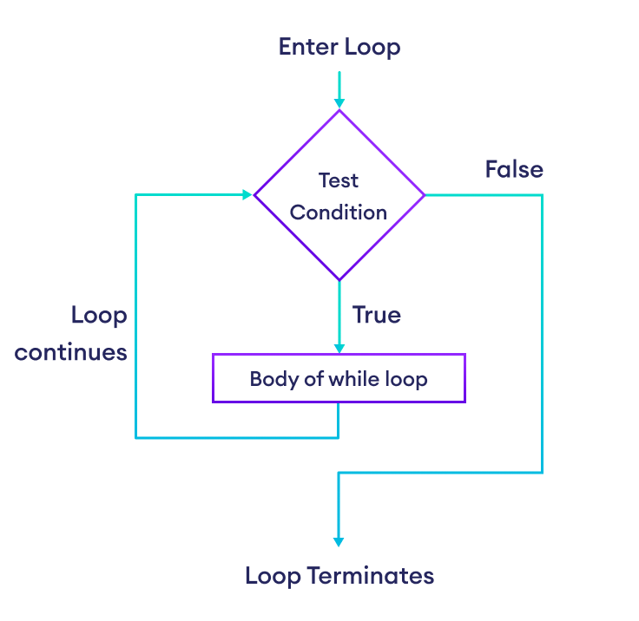Flowchart of Python while Loop

Example: Python while Loop
# Calculate the sum of numbers until user enters 0
number = int(input('Enter a number: '))

total = 0

# iterate until the user enters 0
while number != 0:
total += number
number = int(input('Enter a number: '))

print('The sum is', total)
Run Code
Output
Enter a number: 3
Enter a number: 2
Enter a number: 1
Enter a number: -4
Enter a number: 0
The sum is 2
Here is how the above program works:
- It asks the user to enter a number.
- If the user enters a number other than 0, it adds the number to the total and asks the user to enter a number again.
- If the user enters 0, the loop terminates and the program displays the total.

Infinite while Loop
If the condition of a while loop is always True, the loop runs for infinite times, forming an infinite while loop. For example,
age = 32

# the test condition is always True
while age > 18:
print('You can vote')
Run Code
Output
You can vote
You can vote
You can vote
.
.
.
The above program is equivalent to:
age = 32

# the test condition is always True
while True:
print('You can vote')
Run Code

More on Python while Loop
Python whileloop with breakstatement
Python whileloop with an elseclause
Python for loop vs while loop
The for loop is usually used in the sequence when the number of iterations is known. For example,
# loop is iterated 4 times
for i in range(4):
print(i)
Run Code
Output
0
1
2
3
The while loop is usually used when the number of iterations is unknown. For example,
while True:
user_input = input("Enter password: ")

# terminate the loop when user enters exit
if user_input == 'exit':
print(f'Status: Entry Rejected')
break

print(f'Status: Entry Allowed')
Run Code
Output
Enter password: Python is Fun
Status: Entry Allowed
Enter password: exit
Status: Entry Rejected

Python break and continue
In programming, the break and continue statements are used to alter the flow of loops:
- break exits the loop entirely
- continue skips the current iteration and proceeds to the next one

Python break Statement
The break statement terminates the loop immediately when it's encountered.
Syntax
break

Working of Python break Statement
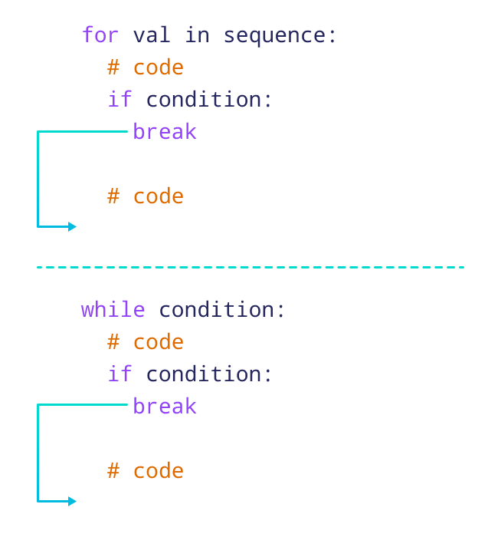Working of break Statement in Python
The above image shows the working of break statements in for and while loops.
Note: The break statement is usually used inside decision-making statements such as if...else.

Example: break Statement with for Loop
We can use the break statement with the for loop to terminate the loop when a certain condition is met. For example,
for i in range(5):
if i == 3:
break
print(i)
Run Code
Output
0
1
2
In the above example,
if i == 3:
break
terminates the loop when i is equal to 3. Hence, the output doesn't include values after 2.
Note: We can also terminate the while loop using a break statement.
break Statement with while Loop

Python continue Statement
The continue statement skips the current iteration of the loop and the control flow of the program goes to the next iteration.
Syntax
continue

Working of continue Statement in Python
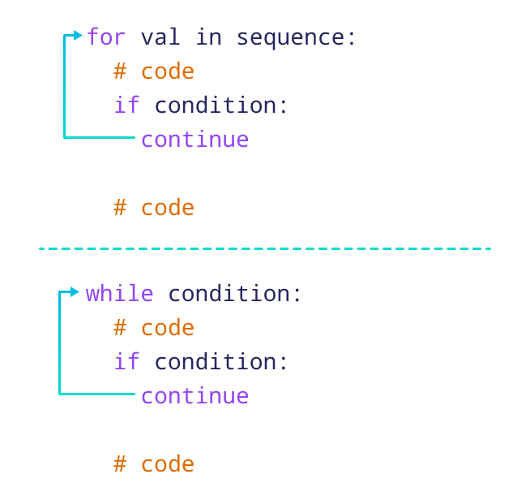

Example: continue Statement with for Loop
We can use the continue statement with the for loop to skip the current iteration of the loop and jump to the next iteration. For example,
for i in range(5):
if i == 3:
continue
print(i)
Run Code
Output
0
1
2
4
In the above example,
if i == 3:
continue
skips the current iteration when i is equal to 3, and continues the next iteration. Hence, the output has all the values except 3.
Note: We can also use the continue statement with a while loop.
Output
0
1
2
4
In the above example,
if i == 3:
continue
skips the current iteration when i is equal to 3, and continues the next iteration. Hence, the output has all the values except 3.

Python pass Statement
In Python programming, the pass statement is a null statement which can be used as a placeholder for future code.
Suppose we have a loop or a function that is not implemented yet, but we want to implement it in the future. In such cases, we can use the pass statement.
The syntax of the pass statement is:
pass

Using pass With Conditional Statement
n = 10

# use pass inside if statement
if n > 10:
pass

print('Hello')
Run Code
Here, notice that we have used the pass statement inside the if statement .
However, nothing happens when the pass is executed. It results in no operation (NOP).
Suppose we didn't use pass or just put a comment as:
n = 10

if n > 10:
# write code later

print('Hello')
Run Code
Here, we will get an error message: IndentationError: expected an indented block
Note: The difference between a comment and a pass statement in Python is that while the interpreter ignores a comment entirely, pass is not ignored.

Use of pass Statement inside Function or Class
We can do the same thing in an empty function or class as well. For example,
def function(args):
pass
class Example:
pass

Python break and continue
In programming, the break and continue statements are used to alter the flow of loops:
- break exits the loop entirely
- continue skips the current iteration and proceeds to the next one

Python break Statement
The break statement terminates the loop immediately when it's encountered.
Syntax
break

Working of Python break Statement
Working of break Statement in Python
The above image shows the working of break statements in for and while loops.
Note: The break statement is usually used inside decision-making statements such as if...else.

Example: break Statement with for Loop
We can use the break statement with the for loop to terminate the loop when a certain condition is met. For example,
for i in range(5):
if i == 3:
break
print(i)
Run Code
Output
0
1
2
In the above example,
if i == 3:
break
terminates the loop when i is equal to 3. Hence, the output doesn't include values after 2.
Note: We can also terminate the while loop using a break statement.
break Statement with while Loop

Python continue Statement
The continue statement skips the current iteration of the loop and the control flow of the program goes to the next iteration.
Syntax
continue

Working of continue Statement in Python


Example: continue Statement with for Loop
We can use the continue statement with the for loop to skip the current iteration of the loop and jump to the next iteration. For example,
for i in range(5):
if i == 3:
continue
print(i)
Run Code
Output
0
1
2
4
In the above example,
if i == 3:
continue
skips the current iteration when i is equal to 3, and continues the next iteration. Hence, the output has all the values except 3.

Python pass Statement
In Python programming, the pass statement is a null statement which can be used as a placeholder for future code.
Suppose we have a loop or a function that is not implemented yet, but we want to implement it in the future. In such cases, we can use the pass statement.
The syntax of the pass statement is:
pass

Using pass With Conditional Statement
n = 10

# use pass inside if statement
if n > 10:
pass

print('Hello')

Python Lists
mylist = ["apple", "banana", "cherry"]

List
Lists are used to store multiple items in a single variable.
Lists are one of 4 built-in data types in Python used to store collections of data, the other 3 are Tuple, Set, and Dictionary, all with different qualities and usage.
Lists are created using square brackets:

ExampleGet your own Python Server
Create a List:
thislist = ["apple", "banana", "cherry"]
print(thislist)

List Items
List items are ordered, changeable, and allow duplicate values.
List items are indexed, the first item has index [0], the second item has index [1] etc.

Ordered
When we say that lists are ordered, it means that the items have a defined order, and that order will not change.
If you add new items to a list, the new items will be placed at the end of the list.
Note: There are some list methods that will change the order, but in general: the order of the items will not change.

Changeable
The list is changeable, meaning that we can change, add, and remove items in a list after it has been created.

Allow Duplicates
Since lists are indexed, lists can have items with the same value:

Example
Lists allow duplicate values:
thislist = ["apple", "banana", "cherry", "apple", "cherry"]
print(thislist)

List Length
To determine how many items a list has, use the len() function:

Example
Print the number of items in the list:
thislist = ["apple", "banana", "cherry"]
print(len(thislist))

List Items - Data Types
List items can be of any data type:

Example
String, int and boolean data types:
list1 = ["apple", "banana", "cherry"]
list2 = [1, 5, 7, 9, 3]
list3 = [True, False, False]
A list can contain different data types:

Example
A list with strings, integers and boolean values:
list1 = ["abc", 34, True, 40, "male"]

type()
From Python's perspective, lists are defined as objects with the data type 'list':
<class 'list'>

Example
What is the data type of a list?
mylist = ["apple", "banana", "cherry"]
print(type(mylist))
The list() Constructor
It is also possible to use the list() constructor when creating a new list.

Example
Using the list() constructor to make a List:
thislist = list(("apple", "banana", "cherry")) # note the double round-brackets
print(thislist)

Python Collections (Arrays)
There are four collection data types in the Python programming language:
- List is a collection which is ordered and changeable. Allows duplicate members.
- Tuple is a collection which is ordered and unchangeable. Allows duplicate members.
- Set is a collection which is unordered, unchangeable*, and unindexed. No duplicate members.
- Dictionary is a collection which is ordered** and changeable. No duplicate members.
thislist = ["apple", "banana", "cherry", "apple", "cherry"]
print(thislist)
['apple', 'banana', 'cherry', 'apple', 'cherry']
list1 = ["abc", 34, True, 40, "male"]
print(list1)
['abc', 34, True, 40, 'male']
thislist = list(("apple", "banana", "cherry"))
print(thislist)
['apple', 'banana', 'cherry']

Access Items
List items are indexed and you can access them by referring to the index number:

Example
Print the second item of the list:
thislist = ["apple", "banana", "cherry"]
print(thislist[1]) banana

thislist = ["apple", "banana", "cherry"]
print(thislist[1])

Python List
In Python, lists allow us to store a sequence of items in a single variable.

Create a Python List
We create a list by placing elements inside square brackets [], separated by commas. For example,
# a list of three elements
ages = [19, 26, 29]
print(ages)

# Output: [19, 26, 29]
Run Code
Here, the ages list has three items.
More on List Creation
Using list() to Create Lists
List Characteristics
Lists are:
- Ordered - They maintain the order of elements.
- Mutable - Items can be changed after creation.
- Allow duplicates - They can contain duplicate values.

Access List Elements
Each element in a list is associated with a number, known as a index.
The index always starts from 0. The first element of a list is at index 0, the second element is at index 1, and so on.
Index of List Elements

Access Elements Using Index
We use index numbers to access list elements. For example,
languages = ['Python', 'Swift', 'C++']

# access the first element
print(languages[0]) # Python

# access the third element
print(languages[2]) # C++
Run Code
Access List Elements

More on Accessing List Elements
Negative Indexing in Python
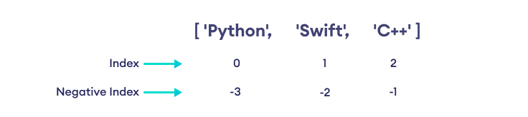
Slicing of a List in Python
Note: If the specified index does not exist in a list, Python throws the IndexError exception.

Add Elements to a Python List
We use the append() method to add an element to the end of a Python list. For example,
fruits = ['apple', 'banana', 'orange']
print('Original List:', fruits)

# using append method
fruits.append('cherry')

print('Updated List:', fruits)
Run Code
Output
Original List: ['apple', 'banana', 'orange']
Updated List: ['apple', 'banana', 'orange', 'cherry']
Add Elements at the Specified Index
Add Elements to a List From Other Iterables

Change List Items
We can change the items of a list by assigning new values using the = operator. For example,
colors = ['Red', 'Black', 'Green']
print('Original List:', colors)

# changing the third item to 'Blue'
colors[2] = 'Blue'

print('Updated List:', colors)
Run Code
Output
Original List: ['Red', 'Black', 'Green']
Updated List: ['Red', 'Black', 'Blue']
Here, we have replaced the element at index 2: 'Green' with 'Blue'.

Remove an Item From a List
We can remove an item from a list using the remove() method. For example,
numbers = [2,4,7,9]

# remove 4 from the list
numbers.remove(4)

print(numbers)

# Output: [2, 7, 9]
Run Code
Remove One or More Elements of a List

Python List Length
We can use the built-in len() function to find the number of elements in a list. For example,
cars = ['BMW', 'Mercedes', 'Tesla']

print('Total Elements: ', len(cars))

# Output: Total Elements: 3
Run Code

Iterating Through a List
We can use a for loop to iterate over the elements of a list. For example,
fruits = ['apple', 'banana', 'orange']

# iterate through the list
for fruit in fruits:
print(fruit)
Run Code
Output
apple
banana
orange

Python List Methods
Python has many useful list methods that make it really easy to work with lists.
Method | Description
append() | Adds an item to the end of the list
extend() | Adds items of lists and other iterables to the end of the list
insert() | Inserts an item at the specified index
remove() | Removes item present at the given index
pop() | Returns and removes item present at the given index
clear() | Removes all items from the list
index() | Returns the index of the first matched item
count() | Returns the count of the specified item in the list
sort() | Sorts the list in ascending/descending order
reverse() | Reverses the item of the list
copy() | Returns the shallow copy of the list

Python Tuple
A tuple is a collection similar to a Python list. The primary difference is that we cannot modify a tuple once it is created.

Create a Python Tuple
We create a tuple by placing items inside parentheses (). For example,
numbers = (1, 2, -5)

print(numbers)

# Output: (1, 2, -5)
Run Code

More on Tuple Creation
Create a Tuple Using tuple() Constructor
Different Types of Python Tuples

Tuple Characteristics
Tuples are:
- Ordered - They maintain the order of elements.
- Immutable - They cannot be changed after creation.
- Allow duplicates - They can contain duplicate values.

Access Tuple Items
Each item in a tuple is associated with a number, known as a index.
The index always starts from 0, meaning the first item of a tuple is at index 0, the second item is at index 1, and so on.

Index of Tuple Item

Access Items Using Index
We use index numbers to access tuple items. For example,
languages = ('Python', 'Swift', 'C++')

# access the first item
print(languages[0]) # Python

# access the third item
print(languages[2]) # C++
Run Code

Access Tuple Items

Tuple Cannot be Modified
Python tuples are immutable (unchangeable). We cannot add, change, or delete items of a tuple.
If we try to modify a tuple, we will get an error. For example,
cars = ('BMW', 'Tesla', 'Ford', 'Toyota')

# trying to modify a tuple
cars[0] = 'Nissan' # error

print(cars)
Run Code

Python Tuple Length
We use the len() function to find the number of items present in a tuple. For example,
cars = ('BMW', 'Tesla', 'Ford', 'Toyota')
print('Total Items:', len(cars))

# Output: Total Items: 4
Run Code

Iterate Through a Tuple
We use the for loop to iterate over the items of a tuple. For example,
fruits = ('apple','banana','orange')

# iterate through the tuple
for fruit in fruits:
print(fruit)
Run Code
Output
apple
banana
orange

Python Sets
A set is a collection of unique data, meaning that elements within a set cannot be duplicated.
For instance, if we need to store information about student IDs, a set is suitable since student IDs cannot have duplicates.
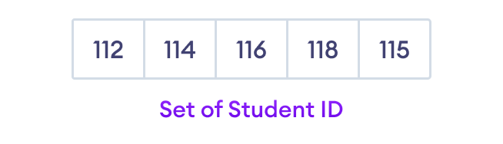Python Set Elements

Create a Set in Python
In Python, we create sets by placing all the elements inside curly braces {}, separated by commas.
A set can have any number of items and they may be of different types (integer, float, tuple, string, etc.). But a set cannot have mutable elements like lists, sets or dictionaries as its elements.
Let's see an example,
# create a set of integer type
student_id = {112, 114, 116, 118, 115}
print('Student ID:', student_id)

# create a set of string type
vowel_letters = {'a', 'e', 'i', 'o', 'u'}
print('Vowel Letters:', vowel_letters)

# create a set of mixed data types
mixed_set = {'Hello', 101, -2, 'Bye'}
print('Set of mixed data types:', mixed_set)
Run Code
Output
Student ID: {112, 114, 115, 116, 118}
Vowel Letters: {'u', 'a', 'e', 'i', 'o'}
Set of mixed data types: {'Hello', 'Bye', 101, -2}
In the above example, we have created different types of sets by placing all the elements inside the curly braces {}.
Note: When you run this code, you might get output in a different order. This is because the set has no particular order.

Create an Empty Set in Python
Creating an empty set is a bit tricky. Empty curly braces {} will make an empty dictionary in Python.
To make a set without any elements, we use the set() function without any argument. For example,
# create an empty set
empty_set = set()

# create an empty dictionary
empty_dictionary = { }

# check data type of empty_set
print('Data type of empty_set:', type(empty_set))

# check data type of dictionary_set
print('Data type of empty_dictionary:', type(empty_dictionary))
Run Code
Output
Data type of empty_set: <class 'set'>
Data type of empty_dictionary: <class 'dict'>
Here,
- empty_set - an empty set created using set()
- empty_dictionary - an empty dictionary created using {}
Finally, we have used the type() function to know which class empty_set and empty_dictionary belong to.

Duplicate Items in a Set
Let's see what will happen if we try to include duplicate items in a set.
numbers = {2, 4, 6, 6, 2, 8}
print(numbers) # {8, 2, 4, 6}
Run Code
Here, we can see there are no duplicate items in the set as a set cannot contain duplicates.

Add and Update Set Items in Python
Sets are mutable. However, since they are unordered, indexing has no meaning.
We cannot access or change an element of a set using indexing or slicing. The set data type does not support it.

Add Items to a Set in Python
In Python, we use the add() method to add an item to a set. For example,
numbers = {21, 34, 54, 12}

print('Initial Set:',numbers)

# using add() method
numbers.add(32)

print('Updated Set:', numbers)
Run Code
Output
Initial Set: {34, 12, 21, 54}
Updated Set: {32, 34, 12, 21, 54}
In the above example, we have created a set named numbers. Notice the line,
numbers.add(32)
Here, add() adds 32 to our set.

Update Python Set
The update() method is used to update the set with items other collection types (lists, tuples, sets, etc). For example,
companies = {'Lacoste', 'Ralph Lauren'}
tech_companies = ['apple', 'google', 'apple']

# using update() method
companies.update(tech_companies)

print(companies)

# Output: {'google', 'apple', 'Lacoste', 'Ralph Lauren'}
Run Code
Here, all the unique elements of tech_companies are added to the companies set.

Remove an Element from a Set
We use the discard() method to remove the specified element from a set. For example,
languages = {'Swift', 'Java', 'Python'}

print('Initial Set:',languages)

# remove 'Java' from a set
removedValue = languages.discard('Java')

print('Set after remove():', languages)
Run Code
Output
Initial Set: {'Python', 'Swift', 'Java'}
Set after remove(): {'Python', 'Swift'}

Python Dictionary
A Python dictionary is a collection of items, similar to lists and tuples. However, unlike lists and tuples, each item in a dictionary is a key-value pair (consisting of a key and a value).

Create a Dictionary
We create a dictionary by placing key: value pairs inside curly brackets {}, separated by commas. For example,
# creating a dictionary
country_capitals = {
"Germany": "Berlin",
"Canada": "Ottawa",
"England": "London"
}

# printing the dictionary
print(country_capitals)
Run Code
Output
{'Germany': 'Berlin', 'Canada': 'Ottawa', 'England': 'London'}
The country_capitals dictionary has three elements (key-value pairs), where 'Germany' is the key and 'Berlin' is the value assigned to it and so on.
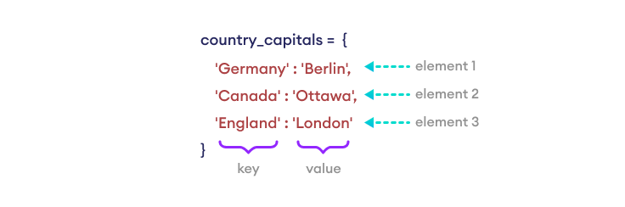Python Dictionary
Notes:
- Dictionary keys must be immutable, such as tuples, strings, integers, etc. We cannot use mutable (changeable) objects such as lists as keys.
- We can also create a dictionary using a Python built-in function dict(). To learn more, visit Python dict().

Valid and Invalid Dictionaries
Keys of a dictionary must be immutable
Keys of a dictionary must be unique

Access Dictionary Items
We can access the value of a dictionary item by placing the key inside square brackets.
country_capitals = {
"Germany": "Berlin",
"Canada": "Ottawa",
"England": "London"
}

# access the value of keys
print(country_capitals["Germany"]) # Output: Berlin
print(country_capitals["England"]) # Output: London
Run Code
Note: We can also use the get() method to access dictionary items.

Add Items to a Dictionary
We can add an item to a dictionary by assigning a value to a new key. For example,
country_capitals = {
"Germany": "Berlin",
"Canada": "Ottawa",
}

# add an item with "Italy" as key and "Rome" as its value
country_capitals["Italy"] = "Rome"

print(country_capitals)
Run Code
Output
{'Germany': 'Berlin', 'Canada': 'Ottawa', 'Italy': 'Rome'}

Remove Dictionary Items
We can use the del statement to remove an element from a dictionary. For example,
country_capitals = {
"Germany": "Berlin",
"Canada": "Ottawa",
}

# delete item having "Germany" key
del country_capitals["Germany"]

print(country_capitals)
Run Code
Output
{'Canada': 'Ottawa'}
Note: We can also use the pop() method to remove an item from a dictionary.
If we need to remove all items from a dictionary at once, we can use the clear() method.
country_capitals = {
"Germany": "Berlin",
"Canada": "Ottawa",
}

# clear the dictionary
country_capitals.clear()

print(country_capitals)
Run Code
Output
{}

Change Dictionary Items
Python dictionaries are mutable (changeable). We can change the value of a dictionary element by referring to its key. For example,
country_capitals = {
"Germany": "Berlin",
"Italy": "Naples",
"England": "London"
}

# change the value of "Italy" key to "Rome"
country_capitals["Italy"] = "Rome"

print(country_capitals)
Run Code
Output
{'Germany': 'Berlin', 'Italy': 'Rome', 'England': 'London'}
Note: We can also use the update() method to add or change dictionary items.

Iterate Through a Dictionary
A dictionary is an ordered collection of items (starting from Python 3.7), therefore it maintains the order of its items.
We can iterate through dictionary keys one by one using a for loop.
country_capitals = {
"United States": "Washington D.C.",
"Italy": "Rome"
}

# print dictionary keys one by one
for country in country_capitals:
print(country)

print()

# print dictionary values one by one
for country in country_capitals:
capital = country_capitals[country]
print(capital)
Run Code
Output
United States
Italy

Washington D.C.
Rome

Find Dictionary Length
We can find the length of a dictionary by using the len() function.
country_capitals = {"England": "London", "Italy": "Rome"}

# get dictionary's length
print(len(country_capitals)) # Output: 2

numbers = {10: "ten", 20: "twenty", 30: "thirty"}

# get dictionary's length
print(len(numbers)) # Output: 3

countries = {}

# get dictionary's length
print(len(countries)) # Output: 0
Run Code

Python Dictionary Methods
Here are some of the commonly used dictionary methods.
Function | Description
pop() | Removes the item with the specified key.
update() | Adds or changes dictionary items.
clear() | Remove all the items from the dictionary.
keys() | Returns all the dictionary's keys.
values() | Returns all the dictionary's values.
get() | Returns the value of the specified key.
popitem() | Returns the last inserted key and value as a tuple.
copy() | Returns a copy of the dictionary.

Dictionary Membership Test
We can check whether a key exists in a dictionary by using the in and not in operators.
file_types = {
".txt": "Text File",
".pdf": "PDF Document",
".jpg": "JPEG Image",
}

# use of in and not in operators
print(".pdf" in file_types) # Output: True
print(".mp3" in file_types) # Output: False
print(".mp3" not in file_types) # Output: True
Run Code
Note: The in operator checks whether a key exists; it doesn't check whether a value exists or not.

Python Functions
A function is a block of code that performs a specific task.
Suppose we need to create a program to make a circle and color it. We can create two functions to solve this problem:
- function to create a circle
- function to color the shape
Dividing a complex problem into smaller chunks makes our program easy to understand and reuse.

Create a Function
Let's create our first function.
def greet():
print('Hello World!')
Here are the different parts of the program:
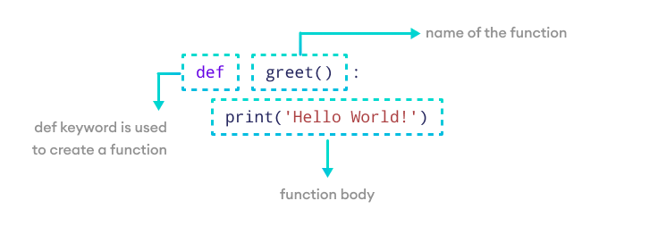Create a Python Function
Here, we have created a simple function named greet() that prints Hello World!
Note: When writing a function, pay attention to indentation, which are the spaces at the start of a code line.
In the above code, the print() statement is indented to show it's part of the function body, distinguishing the function's definition from its body.

Calling a Function
In the above example, we have declared a function named greet().
def greet():
print('Hello World!')
If we run the above code, we won't get an output.
It's because creating a function doesn't mean we are executing the code inside it. It means the code is there for us to use if we want to.
To use this function, we need to call the function.
Function Call
greet()

Example: Python Function Call
def greet():
print('Hello World!')

# call the function
greet()

print('Outside function')
Run Code
Output
Hello World!
Outside function
In the above example, we have created a function named greet(). Here's how the control of the program flows:
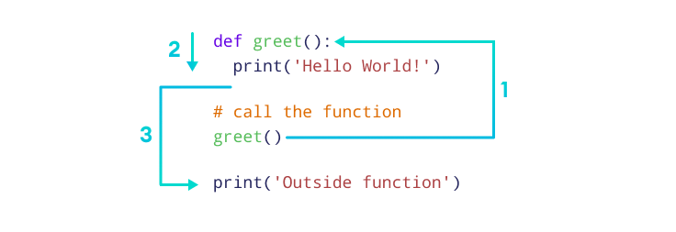Working of Python Function
Here,
- When the function greet() is called, the program's control transfers to the function definition.
- All the code inside the function is executed.
- The control of the program jumps to the next statement after the function call.

Python Function Arguments
Arguments are inputs given to the function.
def greet(name):
print("Hello", name)

# pass argument
greet("John")
Run Code
Sample Output 1
Hello John
Here, we passed 'John' as an argument to the greet() function.
We can pass different arguments in each call, making the function re-usable and dynamic.
Let's call the function with a different argument.
greet("David")
Sample Output 2
Hello David

Example: Function to Add Two Numbers
# function with two arguments
def add_numbers(num1, num2):
sum = num1 + num2
print("Sum: ", sum)

# function call with two values
add_numbers(5, 4)
Run Code
Output
Sum: 9
In the above example, we have created a function named add_numbers() with arguments: num1 and num2.
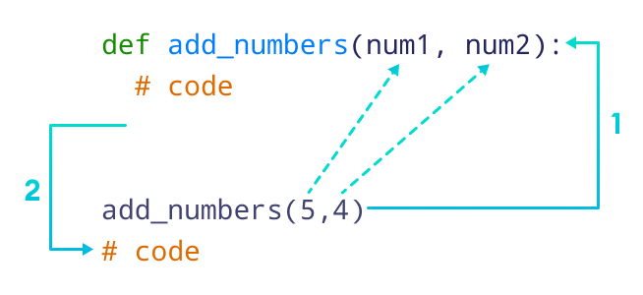Python Function with Arguments
Parameters and Arguments

The return Statement
We return a value from the function using the return statement.
# function definition
def find_square(num):
result = num * num
return result

# function call
square = find_square(3)

print('Square:', square)
Run Code
Output
Square: 9
In the above example, we have created a function named find_square(). The function accepts a number and returns the square of the number.
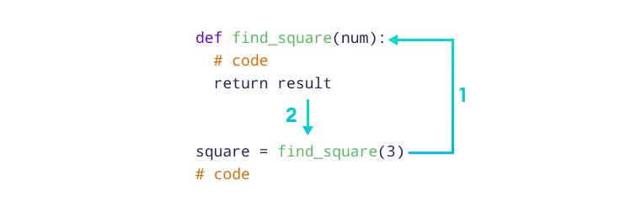Working of functions in Python
Note: The return statement also denotes that the function has ended. Any code after return is not executed.

The pass Statement
The pass statement serves as a placeholder for future code, preventing errors from empty code blocks.
It's typically used where code is planned but has yet to be written.
def future_function():
pass

# this will execute without any action or error
future_function()
Run Code
Note: To learn more, visit Python Pass Statement.

Python Library Functions
Python provides some built-in functions that can be directly used in our program.
We don't need to create the function, we just need to call them.
Some Python library functions are:
- print() - prints the string inside the quotation marks
- Sqrt() - returns the square root of a number
- pow() - returns the power of a number
These library functions are defined inside the module. And to use them, we must include the module inside our program.
For example, sqrt() is defined inside the math module.
Note: To learn more about library functions, please visit Python Library Functions.

Example: Python Library Function
import math

# sqrt computes the square root
square_root = math.sqrt(4)

print("Square Root of 4 is",square_root)

# pow() comptes the power
power = pow(2, 3)

print("2 to the power 3 is",power)
Run Code
Output
Square Root of 4 is 2.0
2 to the power 3 is 8

Python Function Arguments
In computer programming, an argument is a value that is accepted by a function.
Before we learn about function arguments, make sure to know about Python Functions.

Example 1: Python Function Arguments
def add_numbers(a, b):
sum = a + b
print('Sum:', sum)

add_numbers(2, 3)

# Output: Sum: 5
Run Code
In the above example, the function add_numbers() takes two parameters: a and b. Notice the line,
add_numbers(2, 3)
Here, add_numbers(2, 3) specifies that parameters a and b will get values 2 and 3 respectively.

Function Argument with Default Values
In Python, we can provide default values to function arguments.
We use the = operator to provide default values. For example,
def add_numbers( a = 7, b = 8):
sum = a + b
print('Sum:', sum)

# function call with two arguments
add_numbers(2, 3)

# function call with one argument
add_numbers(a = 2)

# function call with no arguments
add_numbers()
Run Code
Output
Sum: 5
Sum: 10
Sum: 15
In the above example, notice the function definition
def add_numbers(a = 7, b = 8):
...
Here, we have provided default values 7 and 8 for parameters a and b respectively. Here's how this program works
1. add_number(2, 3)
Both values are passed during the function call. Hence, these values are used instead of the default values.
2. add_number(2)
Only one value is passed during the function call. So, according to the positional argument 2 is assigned to argument a, and the default value is used for parameter b.
3. add_number()
No value is passed during the function call. Hence, default value is used for both parameters a and b.

Python Keyword Argument
In keyword arguments, arguments are assigned based on the name of the arguments. For example,
def display_info(first_name, last_name):
print('First Name:', first_name)
print('Last Name:', last_name)

display_info(last_name = 'Cartman', first_name = 'Eric')
Run Code
Output
First Name: Eric
Last Name: Cartman
Here, notice the function call,
display_info(last_name = 'Cartman', first_name = 'Eric')
Here, we have assigned names to arguments during the function call.
Hence, first_name in the function call is assigned to first_name in the function definition. Similarly, last_name in the function call is assigned to last_name in the function definition.
In such scenarios, the position of arguments doesn't matter.

Python Function With Arbitrary Arguments
Sometimes, we do not know in advance the number of arguments that will be passed into a function. To handle this kind of situation, we can use arbitrary arguments in Python.
Arbitrary arguments allow us to pass a varying number of values during a function call.
We use an asterisk (*) before the parameter name to denote this kind of argument. For example,
# program to find sum of multiple numbers

def find_sum(*numbers):
result = 0

for num in numbers:
result = result + num

print("Sum = ", result)

# function call with 3 arguments
find_sum(1, 2, 3)

# function call with 2 arguments
find_sum(4, 9)
Run Code
Output
Sum = 6
Sum = 13
In the above example, we have created the function find_sum() that accepts arbitrary arguments. Notice the lines,
find_sum(1, 2, 3)

find_sum(4, 9)

Python Variable Scope
In Python, we can declare variables in three different scopes: local scope, global, and nonlocal scope.
A variable scope specifies the region where we can access a variable. For example,
def add_numbers():
sum = 5 + 4
Here, the sum variable is created inside the function, so it can only be accessed within it (local scope). This type of variable is called a local variable.
Based on the scope, we can classify Python variables into three types:
- Local Variables
- Global Variables
- Nonlocal Variables

Python Local Variables
When we declare variables inside a function, these variables will have a local scope (within the function). We cannot access them outside the function.
These types of variables are called local variables. For example,
def greet():

# local variable
message = 'Hello'

print('Local', message)

greet()

# try to access message variable
# outside greet() function
print(message)
Run Code
Output
Local Hello
NameError: name 'message' is not defined
Here, the message variable is local to the greet() function, so it can only be accessed within the function.
That's why we get an error when we try to access it outside the greet() function.
To fix this issue, we can make the variable named message global.

Python Global Variables
In Python, a variable declared outside of the function or in global scope is known as a global variable. This means that a global variable can be accessed inside or outside of the function.
Let's see an example of how a global variable is created in Python.
# declare global variable
message = 'Hello'

def greet():
# declare local variable
print('Local', message)

greet()
print('Global', message)
Run Code
Output
Local Hello
Global Hello
This time we can access the message variable from outside of the greet() function. This is because we have created the message variable as the global variable.
# declare global variable
message = 'Hello'
Now, message will be accessible from any scope (region) of the program.

Python Nonlocal Variables
In Python, nonlocal variables are used in nested functions whose local scope is not defined. This means that the variable can be neither in the local nor the global scope.
We use the nonlocal keyword to create nonlocal variables. For example,
# outside function
def outer():
message = 'local'

# nested function
def inner():

# declare nonlocal variable
nonlocal message

message = 'nonlocal'
print("inner:", message)

inner()
print("outer:", message)

outer()
Run Code
Output
inner: nonlocal
outer: nonlocal
In the above example, there is a nested inner() function. We have used the nonlocal keywords to create a nonlocal variable.
The inner() function is defined in the scope of another function outer()

Python Strings
In Python, a string is a sequence of characters. For example, "hello" is a string containing a sequence of characters 'h', 'e', 'l', 'l', and 'o'.
We use single quotes or double quotes to represent a string in Python. For example,
# create a string using double quotes
string1 = "Python programming"

# create a string using single quotes
string1 = 'Python programming'
Here, we have created a string variable named string1. The variable is initialized with the string "Python Programming".

Example: Python String
# create string type variables

name = "Python"
print(name)

message = "I love Python."
print(message)
Run Code
Output
Python
I love Python.
In the above example, we have created string-type variables: name and message with values "Python" and "I love Python" respectively.
Here, we have used double quotes to represent strings, but we can use single quotes too.

Access String Characters in Python
We can access the characters in a string in three ways.
- Indexing: One way is to treat strings as a list and use index values. For example,
greet = 'hello'

# access 1st index element
print(greet[1]) # "e"
Run Code
- Negative Indexing: Similar to a list, Python allows negative indexing for its strings. For example,
greet = 'hello'

# access 4th last element
print(greet[-4]) # "e"
Run Code
- Slicing: Access a range of characters in a string by using the slicing operator colon :. For example,
greet = 'Hello'

# access character from 1st index to 3rd index
print(greet[1:4]) # "ell"
Run Code
Note: If we try to access an index out of the range or use numbers other than an integer, we will get errors.

Python Strings are Immutable
In Python, strings are immutable. That means the characters of a string cannot be changed. For example,
message = 'Hola Amigos'
message[0] = 'H'
print(message)
Run Code
Output
TypeError: 'str' object does not support item assignment
However, we can assign the variable name to a new string. For example,
message = 'Hola Amigos'

# assign new string to message variable
message = 'Hello Friends'

print(message); # prints "Hello Friends"
Run Code

Python Multiline String
We can also create a multiline string in Python. For this, we use triple double quotes """ or triple single quotes '''. For example,
# multiline string
message = """
Never gonna give you up
Never gonna let you down
"""

print(message)
Run Code
Output
Never gonna give you up
Never gonna let you down
In the above example, anything inside the enclosing triple quotes is one multiline string.

Python String Operations
Many operations can be performed with strings, which makes it one of the most used data types in Python.

1. Compare Two Strings
We use the == operator to compare two strings. If two strings are equal, the operator returns True. Otherwise, it returns False. For example,
str1 = "Hello, world!"
str2 = "I love Swift."
str3 = "Hello, world!"

# compare str1 and str2
print(str1 == str2)

# compare str1 and str3
print(str1 == str3)
Run Code
Output
False
True
In the above example,
- str1 and str2 are not equal. Hence, the result is False.
- str1 and str3 are equal. Hence, the result is True.

2. Join Two or More Strings
In Python, we can join (concatenate) two or more strings using the + operator.
greet = "Hello, "
name = "Jack"

# using + operator
result = greet + name
print(result)

# Output: Hello, Jack
Run Code
In the above example, we have used the + operator to join two strings: greet and name.

Iterate Through a Python String
We can iterate through a string using a for loop. For example,
greet = 'Hello'

# iterating through greet string
for letter in greet:
print(letter)
Run Code
Output
H
e
l
l
o

Python String Length
In Python, we use the len() method to find the length of a string. For example,
greet = 'Hello'

# count length of greet string
print(len(greet))

# Output: 5
Run Code

String Membership Test
We can test if a substring exists within a string or not, using the keyword in.
print('a' in 'program') # True
print('at' not in 'battle') # False

Python String isnumeric()
The isnumeric() method checks if all the characters in the string are numeric.

Example
pin = "523"

# checks if every character of pin is numeric
print(pin.isnumeric())

# Output: True

Example 1: Python isnumeric()
symbol_number = "012345"

# returns True as symbol_number has all numeric characters
print(string1.isnumeric())

text = "Python3"

# returns False as every character of text is not numeric
print(string2.isnumeric())

Output
True
False

Example 2: isnumeric() with Other Numeric Types
Python treats mathematical characters like numbers, subscripts, superscripts, and characters having Unicode numeric value properties (like a fraction, roman numerals, currency numerators) as numeric characters.
The isnumeric() method returns True with these characters. For example:
# string with superscript
superscript_string = '²3455'
print(superscript_string.isnumeric())

# string with fraction value
fraction_string = '½123'
print(fraction_string.isnumeric())
Run Code
Output
True
True

Python String find()
The find() method returns the index of first occurrence of the substring (if found). If not found, it returns -1.

Example
message = 'Python is a fun programming language'

# check the index of 'fun'
print(message.find('fun'))

# Output: 12

Python String index()
The index() method returns the index of a substring inside the string (if found). If the substring is not found, it raises an exception.

Example
text = 'Python is fun'

# find the index of is
result = text.index('is')

print(result)

# Output: 7

Python String isdecimal()
The syntax of isdecimal() is
string.isdecimal()

isdecimal() Parameters
The isdecimal() doesn't take any parameters.

Return Value from isdecimal()
The isdecimal() returns:
- True if all characters in the string are decimal characters.
- False if at least one character is not decimal character.

Example 1: Working of isdecimal()
s = "28212"
print(s.isdecimal())

# contains alphabets
s = "32ladk3"
print(s.isdecimal())

# contains alphabets and spaces
s = "Mo3 nicaG el l22er"
print(s.isdecimal())
Run Code
Output
True
False
False
The superscript and subscripts are considered digit characters but not decimals. If the string contains these characters (usually written using unicode), isdecimal() returns False.
Similarly, roman numerals, currency numerators and fractions are considered numeric numbers (usually written using unicode) but not decimals. The isdecimal() also returns False in this case.
There are two methods isdigit() and isnumeric() that checks whether the string contains digit characters and numeric characters respectively.
Learn more about isdigit() and isnumeric() methods.

Example 2: String Containing digits and Numeric Characters
s = '23455'
print(s.isdecimal())

#s = '²3455'
s = '\u00B23455'
print(s.isdecimal())

# s = '½'
s = '\u00BD'
print(s.isdecimal())
Run Code
Output
True
False
False

Python String isprintable()
The isprintable() method returns True if all characters in the string are printable. If not, it returns False.

Example
text = 'apple'

# returns True if text is printable
result = text.isprintable()

print(result)

# Output: True

Python Classes and Objects
In the last tutorial, we learned about Python OOP. We know that Python also supports the concept of objects and classes.
An object is simply a collection of data (variables) and methods (functions). Similarly, a class is a blueprint for that object.
Before we learn about objects, let's first learn about classes in Python.

Python Classes
A class is considered a blueprint of objects.
We can think of the class as a sketch (prototype) of a house. It contains all the details about the floors, doors, windows, etc.
Based on these descriptions, we build the house; the house is the object.
Since many houses can be made from the same description, we can create many objects from a class.

Define Python Class
We use the class keyword to create a class in Python. For example,
class ClassName:
# class definition
Here, we have created a class named ClassName.
Let's see an example,
class Bike:
name = ""
gear = 0
Here,
- Bike - the name of the class
- name/gear - variables inside the class with default values "" and 0 respectively.
Note: The variables inside a class are called attributes.

Python Objects
An object is called an instance of a class.
Suppose Bike is a class then we can create objects like bike1, bike2, etc from the class.
Here's the syntax to create an object.
objectName = ClassName()
Let's see an example,
# create class
class Bike:
name = ""
gear = 0

# create objects of class
bike1 = Bike()
Here, bike1 is the object of the class. Now, we can use this object to access the class attributes.

Access Class Attributes Using Objects
We use the . notation to access the attributes of a class. For example,
# modify the name property
bike1.name = "Mountain Bike"

# access the gear property
bike1.gear
Here, we have used bike1.name and bike1.gear to change and access the value of name and gear attributes, respectively.

Example 1: Python Class and Objects
# define a class
class Bike:
name = ""
gear = 0

# create object of class
bike1 = Bike()

# access attributes and assign new values
bike1.gear = 11
bike1.name = "Mountain Bike"

print(f"Name: {bike1.name}, Gears: {bike1.gear} ")
Run Code
Output
Name: Mountain Bike, Gears: 11
In the above example, we have defined the class named Bike with two attributes: name and gear.
We have also created an object bike1 of the class Bike.
Finally, we have accessed and modified the properties of an object using the . notation.

Create Multiple Objects of Python Class
We can also create multiple objects from a single class. For example,
# define a class
class Employee:
# define a property
employee_id = 0

# create two objects of the Employee class
employee1 = Employee()
employee2 = Employee()

# access property using employee1
employee1.employeeID = 1001
print(f"Employee ID: {employee1.employeeID}")

# access properties using employee2
employee2.employeeID = 1002
print(f"Employee ID: {employee2.employeeID}")
Run Code
Output
Employee ID: 1001
Employee ID: 1002
In the above example, we have created two objects employee1 and employee2 of the Employee class.

Python Methods
We can also define a function inside a Python class. A Python function defined inside a class is called a method.
Let's see an example,
# create a class
class Room:
length = 0.0
breadth = 0.0

# method to calculate area
def calculate_area(self):
print("Area of Room =", self.length * self.breadth)

# create object of Room class
study_room = Room()

# assign values to all the properties
study_room.length = 42.5
study_room.breadth = 30.8

# access method inside class
study_room.calculate_area()
Run Code
Output
Area of Room = 1309.0
In the above example, we have created a class named Room with:
- Attributes: length and breadth
- Method: calculate_area()
Here, we have created an object named study_room from the Room class.
We then used the object to assign values to attributes: length and breadth.
Notice that we have also used the object to call the method inside the class,
study_room.calculate_area()
Here, we have used the . notation to call the method. Finally, the statement inside the method is executed.

Python Constructors
Earlier we assigned a default value to a class attribute,
class Bike:
name = ""
...
# create object
bike1 = Bike()
However, we can also initialize values using the constructors. For example,
class Bike:

# constructor function
def __init__(self, name = ""):
self.name = name

bike1 = Bike()
Here, __init__() is the constructor function that is called whenever a new object of that class is instantiated.
The constructor above initializes the value of the name attribute.
We have used the self.name to refer to the name attribute of the bike1 object.
If we use a constructor to initialize values inside a class, we need to pass the corresponding value during the object creation of the class.
bike1 = Bike("Mountain Bike")
Here, "Mountain Bike" is passed to the name parameter of __init__().
Also Read:
- Python inheritance
- Polymorphism in Python
- Python object()
- Python classmethod()

Python Inheritance
Being an object-oriented language, Python supports class inheritance. It allows us to create a new class from an existing one.
- The newly created class is known as the subclass (child or derived class).
- The existing class from which the child class inherits is known as the superclass (parent or base class).

Python Inheritance Syntax
# define a superclass
class super_class:
# attributes and method definition

# inheritance
class sub_class(super_class):
# attributes and method of super_class
# attributes and method of sub_class
Here, we are inheriting the sub_class from the super_class.
Note: Before you move forward with inheritance, make sure you know how Python classes and objects work.

Example: Python Inheritance
class Animal:

# attribute and method of the parent class
name = ""

def eat(self):
print("I can eat")

# inherit from Animal
class Dog(Animal):

# new method in subclass
def display(self):
# access name attribute of superclass using self
print("My name is ", self.name)

# create an object of the subclass
labrador = Dog()

# access superclass attribute and method
labrador.name = "Rohu"
labrador.eat()

# call subclass method
labrador.display()
Run Code
Output
I can eat
My name is Rohu
In the above example, we have derived a subclass Dog from a superclass Animal. Notice the statements,
labrador.name = "Rohu"

labrador.eat()
Here, we are using labrador (object of Dog) to access name and eat() of the Animal class.
This is possible because the subclass inherits all attributes and methods of the superclass.
Also, we have accessed the name attribute inside the method of the Dog class using self.
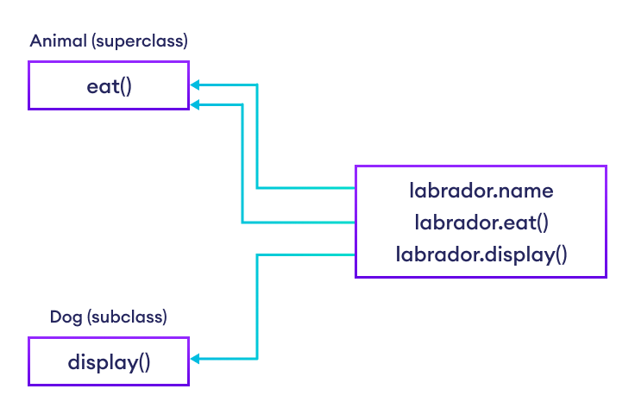
Python Inheritance Implementation

is-a relationship
Inheritance is an is-a relationship. That is, we use inheritance only if there exists an is-a relationship between two classes. For example,
- Car is a Vehicle
- Apple is a Fruit
- Cat is an Animal
Here, Car can inherit from Vehicle, Apple can inherit from Fruit, and so on.

Method Overriding in Python Inheritance
In the previous example, we see the object of the subclass can access the method of the superclass.
However, what if the same method is present in both the superclass and subclass?
In this case, the method in the subclass overrides the method in the superclass. This concept is known as method overriding in Python.

Example: Method Overriding
class Animal:

# attributes and method of the parent class
name = ""

def eat(self):
print("I can eat")

# inherit from Animal
class Dog(Animal):

# override eat() method
def eat(self):
print("I like to eat bones")

# create an object of the subclass
labrador = Dog()

# call the eat() method on the labrador object
labrador.eat()
Run Code
Output
I like to eat bones
In the above example, the same method eat() is present in both the Dog class and the Animal class.
Now, when we call the eat() method using the object of the Dog subclass, the method of the Dog class is called.
This is because the eat() method of the Dog subclass overrides the same method of the Animal superclass.

The super() Function in Inheritance
Previously we saw that the same method (function) in the subclass overrides the method in the superclass.
However, if we need to access the superclass method from the subclass, we use the super() function. For example,
class Animal:

name = ""

def eat(self):
print("I can eat")

# inherit from Animal
class Dog(Animal):

# override eat() method
def eat(self):

# call the eat() method of the superclass using super()
super().eat()

print("I like to eat bones")

# create an object of the subclass
labrador = Dog()

labrador.eat()
Run Code
Output
I can eat
I like to eat bones
In the above example, the eat() method of the Dog subclass overrides the same method of the Animal superclass.
Inside the Dog class, we have used
# call method of superclass
super().eat()
to call the eat() method of the Animal superclass from the Dog subclass.
So, when we call the eat() method using the labrador object
# call the eat() method
labrador.eat()
Both the overridden and the superclass version of the eat() method is executed.
To learn more, visit Python super().

Python Multiple Inheritance
A class can be derived from more than one superclass in Python. This is called multiple inheritance.
For example, a class Bat is derived from superclasses Mammal and WingedAnimal. It makes sense because bat is a mammal as well as a winged animal.

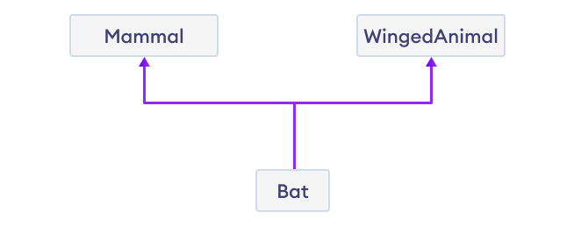
Multiple Inheritance

Python Multiple Inheritance Syntax
class SuperClass1:
# features of SuperClass1

class SuperClass2:
# features of SuperClass2

class MultiDerived(SuperClass1, SuperClass2):
# features of SuperClass1 + SuperClass2 + MultiDerived class
Here, the MultiDerived class is derived from SuperClass1 and SuperClass2 classes.

Example: Python Multiple Inheritance
class Mammal:
def mammal_info(self):
print("Mammals can give direct birth.")

class WingedAnimal:
def winged_animal_info(self):
print("Winged animals can flap.")

class Bat(Mammal, WingedAnimal):
pass

# create an object of Bat class
b1 = Bat()

b1.mammal_info()
b1.winged_animal_info()
Run Code
Output
Mammals can give direct birth.
Winged animals can flap.
In the above example, the Bat class is derived from two super classes: Mammal and WingedAnimal. Notice the statements,
b1 = Bat()
b1.mammal_info()
b1.winged_animal_info()
Here, we are using b1 (object of Bat) to access mammal_info() and winged_animal_info() methods of the Mammal and the WingedAnimal class respectively.

Python Multilevel Inheritance
In Python, not only can we derive a class from the superclass but you can also derive a class from the derived class. This form of inheritance is known as multilevel inheritance.
Here's the syntax of the multilevel inheritance,
class SuperClass:
# Super class code here

class DerivedClass1(SuperClass):
# Derived class 1 code here
# Derived class 2 code here
Here, the DerivedClass1 class is derived from the SuperClass class, and the DerivedClass2 class is derived from the DerivedClass1 class.
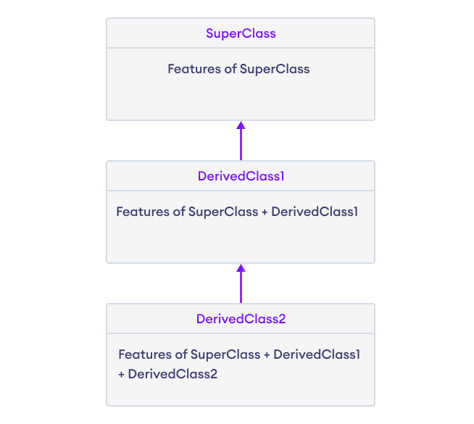
Multilevel Inheritance in Python

Example: Python Multilevel Inheritance
class SuperClass:

def super_method(self):
print("Super Class method called")

# define class that derive from SuperClass
class DerivedClass1(SuperClass):
def derived1_method(self):
print("Derived class 1 method called")

# define class that derive from DerivedClass1
class DerivedClass2(DerivedClass1):

def derived2_method(self):
print("Derived class 2 method called")

# create an object of DerivedClass2
d2 = DerivedClass2()

d2.super_method() # Output: "Super Class method called"

d2.derived1_method() # Output: "Derived class 1 method called"

d2.derived2_method() # Output: "Derived class 2 method called"
Run Code
Output
Super Class method called
Derived class 1 method called
Derived class 2 method called
In the above example, DerivedClass2 is derived from DerivedClass1, which is derived from SuperClass.
It means that DerivedClass2 inherits all the attributes and methods of both DerivedClass1 and SuperClass.
Hence, we are using d2 (object of DerivedClass2) to call methods from SuperClass, DerivedClass1, and DerivedClass2.

Method Resolution Order (MRO) in Python
If two superclasses have the same method (function) name and the derived class calls that method, Python uses the MRO to search for the right method to call. For example,
class SuperClass1:
def info(self):
print("Super Class 1 method called")

class SuperClass2:
def info(self):
print("Super Class 2 method called")

class Derived(SuperClass1, SuperClass2):
pass

d1 = Derived()
d1.info()

# Output: "Super Class 1 method called"
Run Code
Here, SuperClass1 and SuperClass2 both of these classes define a method info().
So when info() is called using the d1 object of the Derived class, Python uses the MRO to determine which method to call.
In this case, the MRO specifies that methods should be inherited from the leftmost superclass first, so info() of SuperClass1 is called rather than that of SuperClass2.

